February 24, 2021

Dear Parents and Carers,

As you will be aware, the government has said that from 8th March all children should return to school. We are very much looking forward to welcoming back those pupils we have not seen since before Christmas and I am sure that for many of you, you will be very pleased that schools are fully re-opening.

Attendance will be mandatory, unless your child has a medical condition that means they are clinically extremely vulnerable (CEV) or if they need to self-isolate.

If you have any concerns about your child returning to school please contact myself or a member of the senior leadership team to discuss, either by calling the school office or by emailing us directly.

In consultation with Lewisham Public Health and taking into account all Government Guidance, I am in the process of revising our Covid-19 Risk Assessment, which will be published on the school website next week. Please be reassured that we are putting every possible measure into place to make sure the school is as safe as possible for our pupils and staff.

We were fortunate that Lewisham categorised the school’s staff alongside health and social care workers, so everyone has been offered the opportunity to have a Covid-19 vaccination. We also offer all staff the opportunity to have a lateral flow test twice a week.

We hope to avoid any further disruption to your child’s education, but must bear in mind that should we have confirmed cases of the virus we will continue to need to ask individuals and bubbles to self-isolate. I would also ask you to follow all government guidance for self-isolation should you or a member of your family receive a positive coronavirus test result and to be sure you inform the school using the following number: 07825 111559.

I would like to thank-you again for your patience during this lock-down and congratulate you on the fantastic home learning you have done with your children. We know that it has not been an easy time, but hopefully the situation will continue to improve.

Yours sincerely

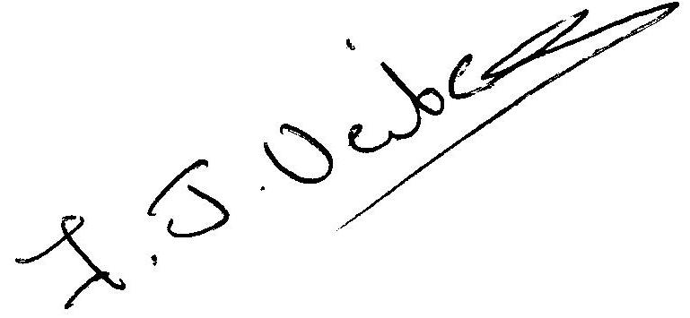

Fiona Veitch
Interim Headteacher

